Reflective Rearrangement

Definition
# Source: AI Source: Provided by: [Data Path: Persons Table -> ID Column: 1, Name_En Column: Motasem Essam] -> From: [ChatGPT] on [7/25/2026]
Reflective Rearrangement is a type of geometric figure rearrangement in which a figure or one or more of its pieces are reflected across a line to create a new arrangement.
A reflection produces a mirror image of the original figure across a line of reflection. The figure retains its shape, size, side lengths, angles, and area, but its orientation is reversed.

Simple Definition
# Source: AI Source: Provided by: [Data Path: Persons Table -> ID Column: 1, Name_En Column: Motasem Essam] -> From: [ChatGPT] on [7/25/2026]
Reflective rearrangement means flipping a geometric figure or piece across a line to help it fit into a new arrangement.
Example
A triangular piece is reflected across a vertical line so that its sloping edge faces the opposite direction and matches the edge of another piece.

Main Classification of Reflective Rearrangement
# Source: AI Source: Provided by: [Data Path: Persons Table -> ID Column: 1, Name_En Column: Motasem Essam] -> From: [ChatGPT] on [7/25/2026]
The following is a practical classification based on how reflection is used during rearrangement. These categories can overlap and are not a universally standardized taxonomy.

1. Vertical Reflection Rearrangement
# Source: AI Source: Provided by: [Data Path: Persons Table -> ID Column: 1, Name_En Column: Motasem Essam] -> From: [ChatGPT] on [7/25/2026]
A piece is reflected across a vertical line, reversing its left-right orientation.
Example: A triangle with its sloping edge on the right is reflected so that the sloping edge appears on the left, allowing it to fit against another piece.
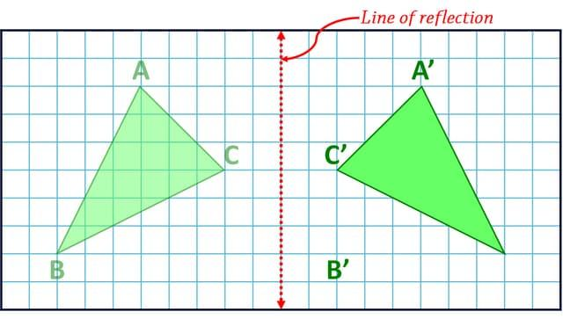

2. Horizontal Reflection Rearrangement
# Source: AI Source: Provided by: [Data Path: Persons Table -> ID Column: 1, Name_En Column: Motasem Essam] -> From: [ChatGPT] on [7/25/2026]
A piece is reflected across a horizontal line, reversing its top-bottom orientation.
Example: A triangular piece pointing upward is reflected across a horizontal line so that its tip points downward and fits into a gap.
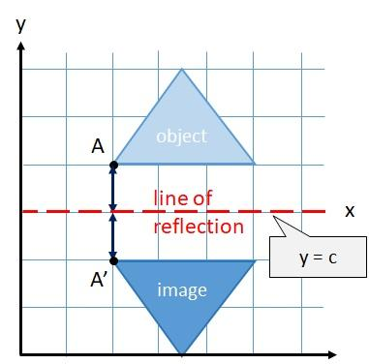

3. Diagonal Reflection Rearrangement
A piece is reflected across a diagonal line rather than a horizontal or vertical line.
Example: A triangular piece is reflected across a diagonal line so that its sloping side aligns with the diagonal boundary of another piece.
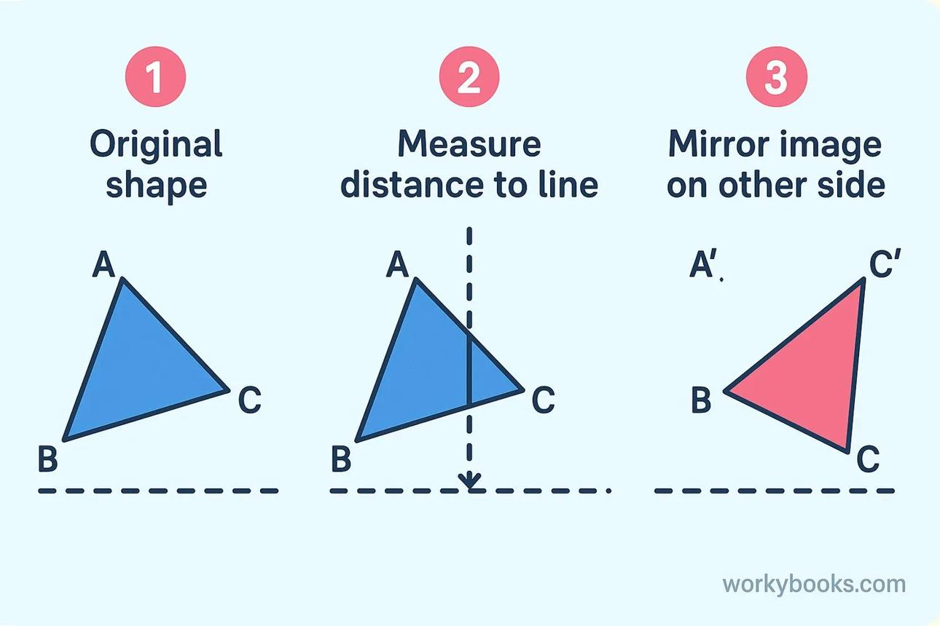

4. Whole-Figure Reflective Rearrangement
# Source: AI Source: Provided by: [Data Path: Persons Table -> ID Column: 1, Name_En Column: Motasem Essam] -> From: [ChatGPT] on [7/25/2026]
The entire geometric figure is reflected as one object across a line.
Example: An L-shaped arrangement is reflected across a vertical line to produce its mirror-image arrangement on the opposite side.
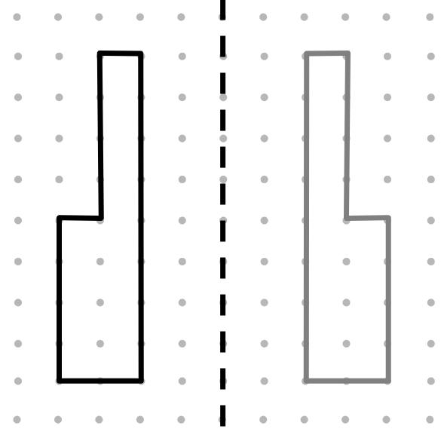

5. Individual-Piece Reflective Rearrangement
# Source: AI Source: Provided by: [Data Path: Persons Table -> ID Column: 1, Name_En Column: Motasem Essam] -> From: [ChatGPT] on [7/25/2026]
Only one piece or a selected group of pieces is reflected, while the remaining pieces stay in their original positions.
Example: One triangular piece in a tangram puzzle is flipped to make its sloping edge match the boundary of an empty region.
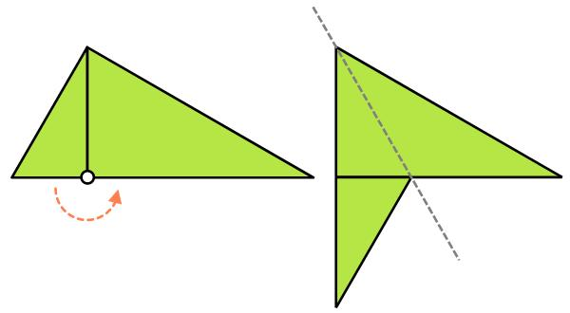

6. Line-of-Symmetry Rearrangement
# Source: AI Source: Provided by: [Data Path: Persons Table -> ID Column: 1, Name_En Column: Motasem Essam] -> From: [ChatGPT] on [7/25/2026]
A piece is reflected across a line that acts as an axis of symmetry for the resulting arrangement.
Example: A polygon on one side of a vertical line is reflected to the other side, creating a symmetrical figure.

7. Edge-Matching Reflective Rearrangement
# Source: AI Source: Provided by: [Data Path: Persons Table -> ID Column: 1, Name_En Column: Motasem Essam] -> From: [ChatGPT] on [7/25/2026]
A piece is reflected specifically to align one of its edges with the edge of another piece.
Example: A triangle is flipped so that its sloping edge faces an adjacent triangle, allowing the two pieces to form a larger polygon.
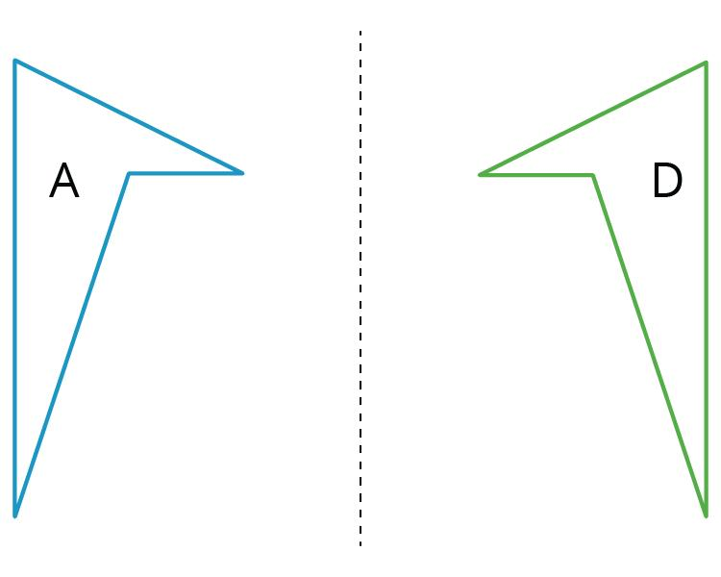

8. Sequential Reflective Rearrangement
# Source: AI Source: Provided by: [Data Path: Persons Table -> ID Column: 1, Name_En Column: Motasem Essam] -> From: [ChatGPT] on [7/25/2026]
Two or more pieces are reflected one after another to create the final arrangement.
Example: Several triangular pieces are flipped in sequence so that their edges align and the pieces form a larger geometric pattern.
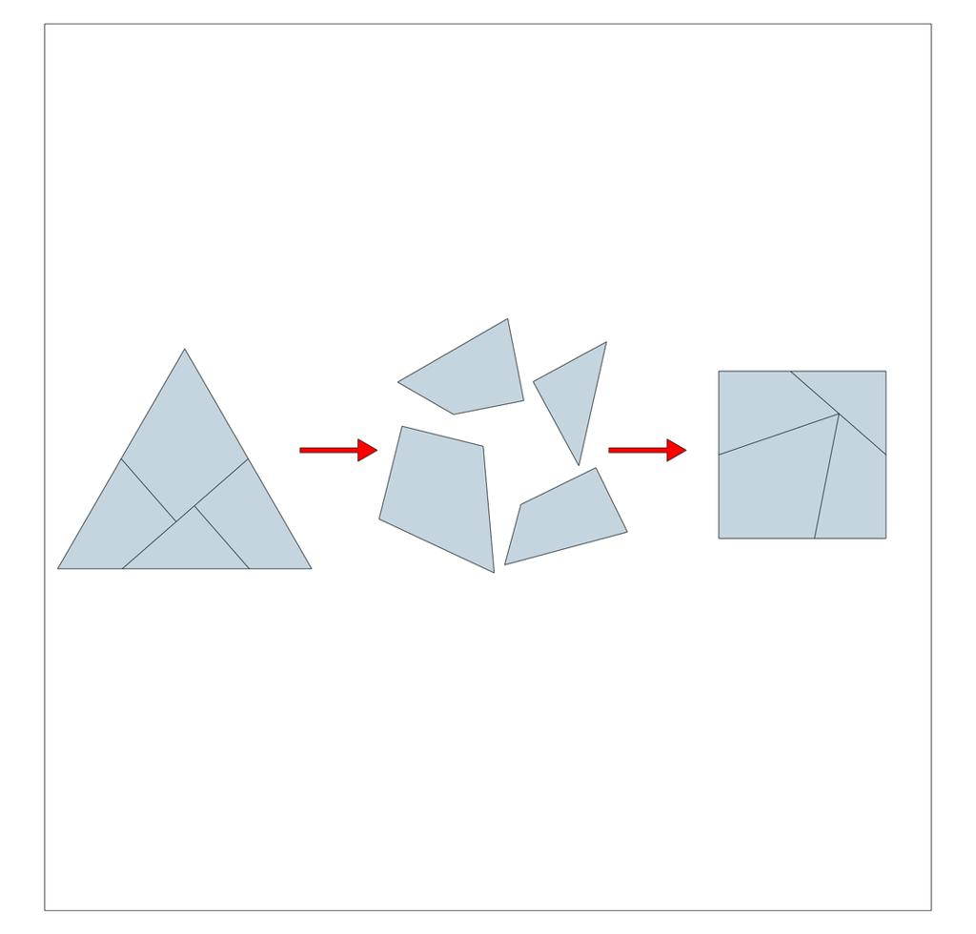

Mathematical Representation of Reflective Rearrangement
# Source: AI Source: Provided by: [Data Path: Persons Table -> ID Column: 1, Name_En Column: Motasem Essam] -> From: [ChatGPT] on [7/25/2026]
A reflection is defined by a line of reflection. Each point and its image lie on opposite sides of the line at equal perpendicular distances from it.
The general notation is:
$$P'=R_{l}\left(P\right)$$
where $P$ is the original point, $P'$ is its reflected image, and $l$ is the line of reflection.
Common coordinate rules
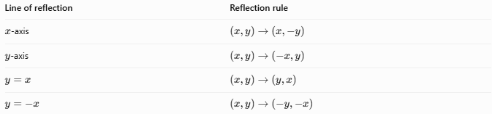
Line of reflection | Reflection rule
$x$-axis | $$\left(x,y\right)→\left(x,-y\right)$$
$y$-axis | $$\left(x,y\right)→\left(-x,y\right)$$
$$y=x$$ | $$\left(x,y\right)→\left(y,x\right)$$
$$y=-x$$ | $$\left(x,y\right)→\left(-y,-x\right)$$
For reflection across the vertical line $x=h$:
$$\left(x,y\right)→\left(2h-x,y\right)$$
For reflection across the horizontal line $y=k$:
$$\left(x,y\right)→\left(x,2k-y\right)$$

Detailed Mathematical Example
# Source: AI Source: Provided by: [Data Path: Persons Table -> ID Column: 1, Name_En Column: Motasem Essam] -> From: [ChatGPT] on [7/25/2026]
Suppose a triangular piece has vertices
$$A=\left(1,1\right), B=\left(4,1\right), C=\left(2,3\right)$$
Reflect the triangle across the $y$-axis.
The reflection rule is:
$$\left(x,y\right)→\left(-x,y\right)$$
Therefore, the reflected vertices are:
$$\begin{aligned}A'&=\left(-1,1\right) \\ B'&=\left(-4,1\right) \\ C'&=\left(-2,3\right)\end{aligned}$$
The reflected triangle has the same side lengths and area as the original triangle, but its left-right orientation is reversed. This can allow it to fit into a space that the original orientation could not fit.

Properties of Reflective Rearrangement
# Source: AI Source: Provided by: [Data Path: Persons Table -> ID Column: 1, Name_En Column: Motasem Essam] -> From: [ChatGPT] on [7/25/2026]
- Shape preservation: The original figure and its reflected image are congruent.
- Length preservation: All corresponding side lengths remain equal.
- Angle preservation: All corresponding angles retain their measures.
- Area preservation: The area remains unchanged.
- Equal perpendicular distances: Each point and its image are equally distant from the reflection line.
- Perpendicular connecting segment: The line of reflection perpendicularly bisects the segment joining a point to its image, except when the point lies on the reflection line, in which case it remains fixed.
- Orientation reversal: A reflection reverses the orientation of a planar figure.
- Fixed line: Every point on the reflection line remains unchanged.

Reflective Rearrangement vs. Other Rearrangement Types
# Source: AI Source: Provided by: [Data Path: Persons Table -> ID Column: 1, Name_En Column: Motasem Essam] -> From: [ChatGPT] on [7/25/2026]
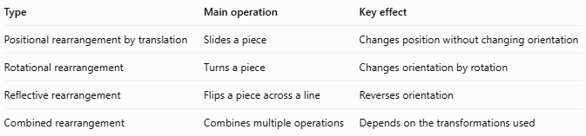
Type | Main operation | Key effect
Positional rearrangement by translation | Slides a piece | Changes position without changing orientation
Rotational rearrangement | Turns a piece | Changes orientation by rotation
Reflective rearrangement | Flips a piece across a line | Reverses orientation
Combined rearrangement | Combines multiple operations | Depends on the transformations used
Important distinction: Reflection is not the same as rotation. A reflected figure is a mirror image, whereas a rotated figure is turned around a center. Reflection may be necessary when a piece must face the opposite way to fit a puzzle or geometric dissection.

Classification Summary
# Source: AI Source: Provided by: [Data Path: Persons Table -> ID Column: 1, Name_En Column: Motasem Essam] -> From: [ChatGPT] on [7/25/2026]
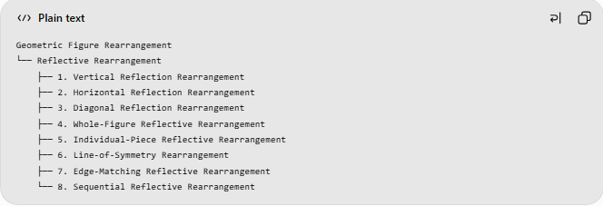
Geometric Figure Rearrangement
└── Reflective Rearrangement
├── 1. Vertical Reflection Rearrangement
├── 2. Horizontal Reflection Rearrangement
├── 3. Diagonal Reflection Rearrangement
├── 4. Whole-Figure Reflective Rearrangement
├── 5. Individual-Piece Reflective Rearrangement
├── 6. Line-of-Symmetry Rearrangement
├── 7. Edge-Matching Reflective Rearrangement
└── 8. Sequential Reflective Rearrangement
These are practical descriptive categories, not mutually exclusive mathematical classes. For example, an individual triangular piece can undergo a vertical reflection specifically to match an edge.

Key Points
# Source: AI Source: Provided by: [Data Path: Persons Table -> ID Column: 1, Name_En Column: Motasem Essam] -> From: [ChatGPT] on [7/25/2026]
- Reflective rearrangement uses a reflection to change the orientation of a figure or piece.
- The reflected image preserves lengths, angles, shape, size, and area.
- The reflection line is the perpendicular bisector of the segment joining each point to its image.
- Reflection reverses orientation and produces a mirror image.
- It is useful in geometric puzzles, figure dissection, tiling, symmetry, and shape assembly.

Conclusion
# Source: AI Source: Provided by: [Data Path: Persons Table -> ID Column: 1, Name_En Column: Motasem Essam] -> From: [ChatGPT] on [7/25/2026]
Reflective Rearrangement is a method of rearranging geometric figures by flipping pieces across a line to achieve a desired configuration. It preserves the dimensions of each piece while reversing its orientation, making it useful when pieces need to face the opposite direction to fit together.

